**User Guide**

**Interface**

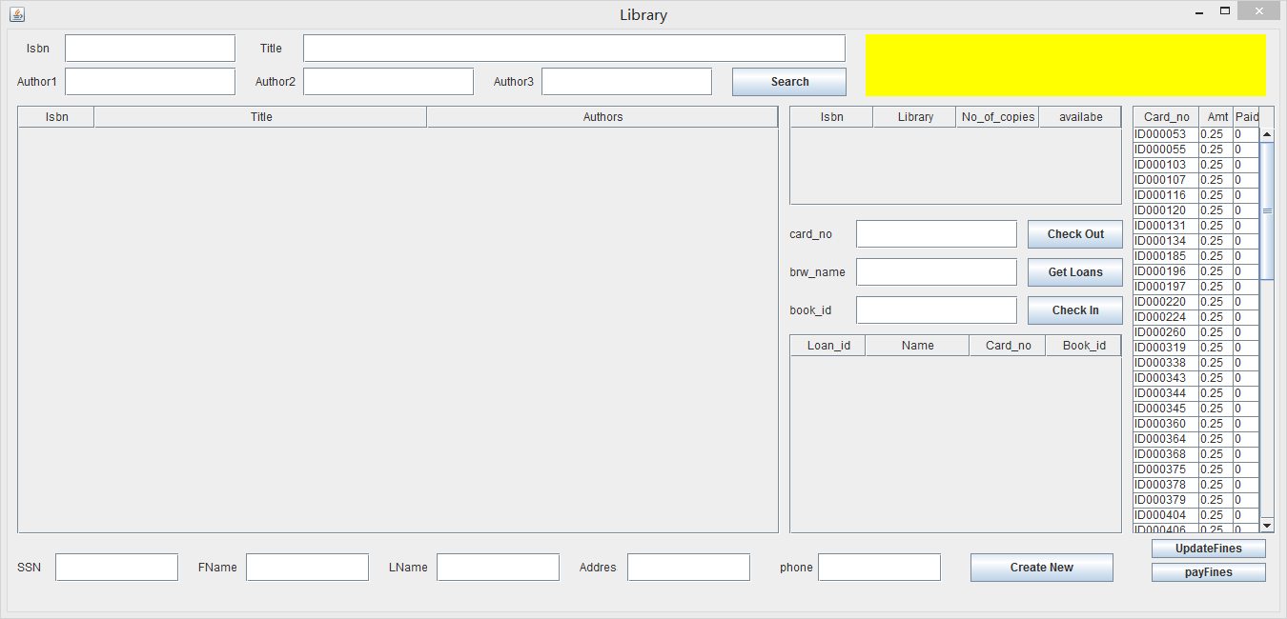

**message field**

**Fine Table**

**Copy Table**

**Loan Table**

**Search Result Table**

**Search**

1. Input values to Isbn, Title, Author1, Author2 and Author3 blanks. You can input any number of blanks according to your requirements. The result will be all the books of all the autors. Isbn should be correct. The other four can be part of the title or author name.
2. Click the Search button. The result will be displayed in the Search Result Table.

**getCopy**

1. Click any row of the search result table, the result of copy in each branch will be displayed in the copy table.

**Checkout**

1. Click any row of the copy table.
2. Input the card number in card_no blank.
3. Click the Check Out button to check out selected book.

**Getloans**

1. Input the card number in card_ no blank or the borrower name in brw_name blank or isbn in book_id blank. Must input at least one blank.
2. Click GetLoans button to display all the loans on certain conditions in the Loan table.

**Checkin**

1. Click any row of the loan table.
2. Click check in button to checkin.

**Update Fines**

1. Click the updateFines button to update the Fine Table

**Payfines**

1. Click any row of the Fine Table
2. Click payfines button to pay the fines.

**CreateBorrower**

1. Input values to Ssn, Fname, Lname, Address, Phone blanks. Ssn should be nine bits.

Phone should be 10 bits.

1. Ssn, Address blanks can’t be empty.
2. Click the Create New button to create new borrower, borrower number will be displayed in the message field.

**Error Message**

Any error message will be displayed in message field.